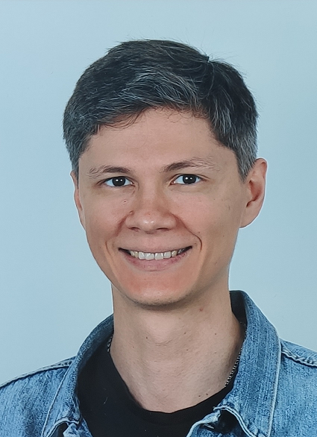 | Maxim Sheshukov
   | Berlin, Germany
   | +4915256004078
   | sheshukovmaxim@gmail.com
   | go-maxus-go
A results-oriented software engineer with more than 7 years of work experience. Well-versed in producing efficient, reusable and readable code. Initiative and creative, constantly looking for ways for improvement. Some of my personal projects are Foody (Flutter), Marbles Puzzle (Qt, QML), di (C++).

Work experience

Software Engineer C++  06/2019 - nowadays | BinarySpaces, Berlin, Germany  ● Reduced project save time by 50% by implementing data cache in RAM.  ● Implemented a release MVP feature Rotary Table for machine setup.
Lead Software Engineer C++/Qt  11/2018 - 03/2019 | Escape Technology, Moscow, Russia  ● Moving avatars like in Telegram .
Software Engineer C++  01/2018 - 11/2018 | Luxoft, Moscow, Russia  ● Added a debugger for Lua scripts.
Software Engineer C++/Qt  10/2017 - 12/2017 | 2GIS, Novosibirsk, Russia  ● Implemented the algorithm for choosing the fastest server.
Software Engineer C++/Qt  03/2016 - 10/2017 | Movavi, Novosibirsk, Russia  ● Implemented a Slideshow Maker that became a successful product.
Software Engineer C++  11/2013 - 03/2016 | SoftLab-NSK, Novosibirsk, Russia  ● Designed a no bullets biathlon training system for children.

Education

Computer science / Physics  master's degree  09/2006 - 06/2012 | Novosibirsk State University, Novosibirsk, Russia  ● Section of automation of physical and technical research. Department of physics.

Skills

  Coding
  C++, STL, Qt, QML | ●●●●●
  Dart, Flutter | ●●●●○
  Boost | ●●●○○
  Development
  Git, CI, CD | ●●●●●
  OOP, SOLID, TDD | ●●●●○
  Algorithms, patterns | ●●●●○
  Languages
  Russian | ●●●●●
  English | ●●●●○
  German | ●●○○○

Hobbies

 |  |  |  | 
Programming | AI | Traveling | Reading | Computer Games

Strengths

Quick learning | Critical thinking | Teamwork | Reliability | Initiative | Leadership

